Exercise

Identifying different types of questions

Time: | 60 minutes
Instructions: | - Form groups of 3 people  - Read “How to Identify Different Types of Questions”  - Try to formulate a few examples of direct, leading, open and probing questions?  - Read and discuss the two dialogues (A and B) between a researcher and a farmer  - For each dialogue, classify the questions into different types? Mark direct questions with a D; leading questions with an L, open questions with an O and probing questions with a P.  - Rewrite some of dialogue A using open and probing questions.  - How did dialogues A and B differ?  - For each dialogue, identify and discuss  - what the researcher did well?  - what the researcher did poorly?

Dialogue A

The researcher (R) arrives at the farmer's (F) house:

R Good morning, how are you?

F What a surprise, you finally came to see us! (comes out to meet him)

R Mr. Soman, the farm looks very nice...now tell me, how is the trial doing?
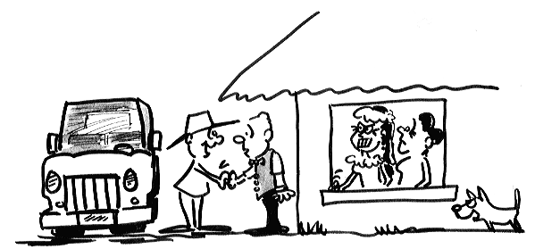
F Well, more or less...Today I haven't been able to visit the trial because we're preparing for the wedding of my daughter. Nobody works today.

R Ah, don't worry, I won't take long, I just have a few questions...We can go and come back quickly. Let's go quickly. We won't take long, Mr. Soman.

F Umm... (with disdain) Let's go! (They reach the trial)

R Mr. Soman, as I mentioned before, I want you to tell me honestly what you think about this trial. What works and what doesn't work? Everything you can tell me about the trial, whether positive or negative, is very useful for me. So, why don't we start. Let's begin with the forage plot you like best up to now, or whichever plot you want to show me.

F (Heads toward a plot) Well, this grass looks pretty good.

R What do you mean when you say this grass looks good?

F Well, that it grows well.

R Are you referring to the bunch-type growth habit of the plant??

F Well, I don't know....It's...how would I say it...pretty tall?

R And why do you think this is good?

F Well, I need a grass for cut-and-carry, so taller plants are easier to cut.

R Well, actually this is not the best grass for cut-and-carry in your area. A better grass would be the one over there, since it is more resistant to cutting.

F What about this plant? It looks good, don't you agree?
R You are quite right, this is the plant type which we are looking for. Now, what more can you tell me about this species?

F It is a very good forage legume.

R Why is it good?

F It has a lot of leaves and I can sell the seed as well. That's more or less what every farmer looks for...

R (Interrupts) And what about disease and pest resistance?

F Good. But of course, "aphids" attack these legumes.

R Okay, it's affected. (records this information). Are any of these legumes more resistant to "aphids"?

Dialogue B

The farmer (F) is working in the field. The researcher (R) appears:

R Good morning, Mr. Soman. How are you?

F Good morning. I'm fine, thanks, and how are you?

R Fine, thanks. How's your family?

F Well, more or less... thanks. As you see, we're real busy weeding this plot.

R I came to ask whether you have time to visit the forage trial so you can tell me what you think about it, how's it going. I'd like to ask you a few questions. It might take about half an hour. But if you're too busy, I can come back later.

F That's all right. I can rest from this weeding. Let's go and see the trial (F and R move toward another part of the field).

R The reason for my visit is that I'd like to look at each one of the plots with you, so you can tell me what you've observed so far about the new forage species. I'd also like to know about any other ideas. Have you noticed anything special, Mr. Soman?

F Well, it seems to be going well. Everything is uniform. The trial looks nice.

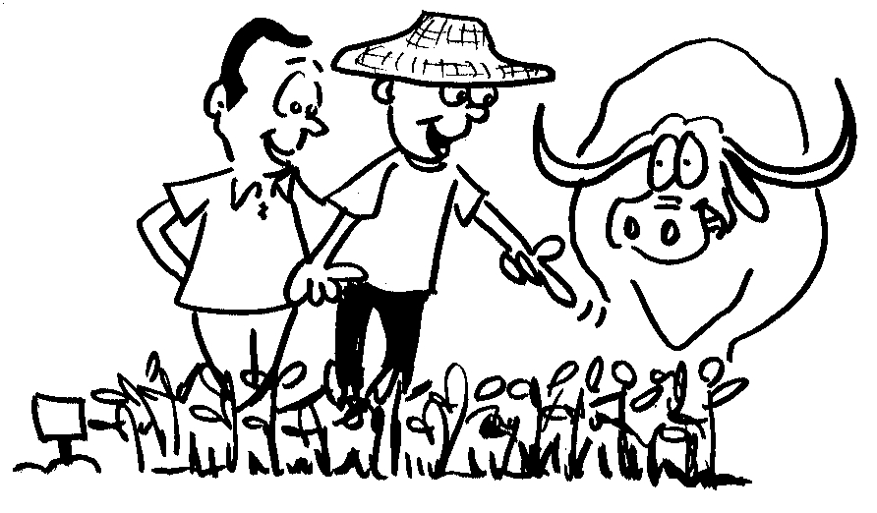
R Do you know that some of your neighbours commented that a few of the new forages have been affected by the dry season? Other farmers in the area do not agree; they don't consider this a problem. I'd like to understand this better. What do you think?

F (Heads toward a plot, R follows). Well, then, this grass was the best species in the wet season, but now all its leaves are brown and my animals don’t like it anymore.

R Aha. (Records this information on the form).

F On the other hand, this legume is still green and I can use it to feed my animals even now that everything else has dried up.

R Have you noted any other difference that you think is important?

F Well...I noticed that my animals eat more of the rice straw when I also give them leaves of this legume, but I think I have to plant the legume in rows not in a big block as we do in these plots.

R You want to plant it in rows? Why?

F Because I can grow it around all of my fields and it will be easy to harvest the leaves.

How to

Identify different types

of questions

Questions can be phrased in many different ways. Depending on how a question is phrased it gives the listener different messages.



Direct questions:

Direct questions are used to ask for specific information such as

“How many bags of urea do you put on this field?”

Direct questions are fine when seeking particular information but should not be used when evaluating technologies with farmers, since these can be leading.



Leading questions:

Leading questions tell the farmer what you would like to hear, and must be avoided at all costs! An example is

“This is a nice plant type, isn’t it?”

Leading questions should not be used.



Open-ended questions:

Open-ended questions invite the farmer to say whatever he wants. They do not suggest what answer the researcher expects.

Open-ended questions are the most often used type of questions when evaluating technologies with farmers. These often include “Why? What? How? When?”.
Some examples are:

“What do you think about these forages?”
“What have you observed?”
“How is the trial going?”
“What is your experience with these forages?”
“Can you tell me more about this plant?”


Probing questions:

Probing is used to follow up on answers of farmers to gain more insight or detail into what the farmer says. This type of question is very important in evaluations with farmers. Some examples are:

Farmer: “This grass looks good.”
Probing: “What do you mean by good”?

Farmer: “This legume has a good colour.”
Probing: “What is it about the colour that you like?”

Farmer: “This grass is easier to grow.
Probing: “How can you tell that it is easier to grow?”

